### Report

|  |  |
| --- | --- |
| Date | 24 may 2023 |
| Team ID | NM2023TMID03508 |
| Student Roll Number | Estimation and prediction of hospitalization and medical care costs |

### Report

A report is a document that presents information in a specific format and layout,

usually based on data from a database or other data source. A report in IBM

Cognos can contain various elements, such as tables, charts, graphs, and images,

as well as text and data elements, and it is designed to be used by business users

to help them better understand their data and make informed decisions. There

are several different types of reports available in IBM Cognos, including list

reports, crosstab reports, chart reports, and report studio reports, among others.

The type of report that you choose will depend on the specific needs and

requirements of your organization, as well as the data that you need to present.

### 

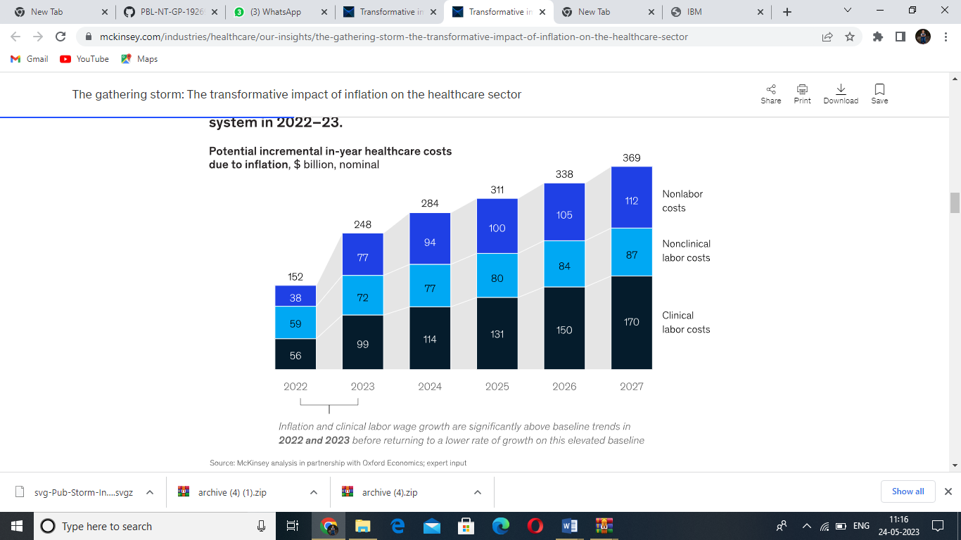

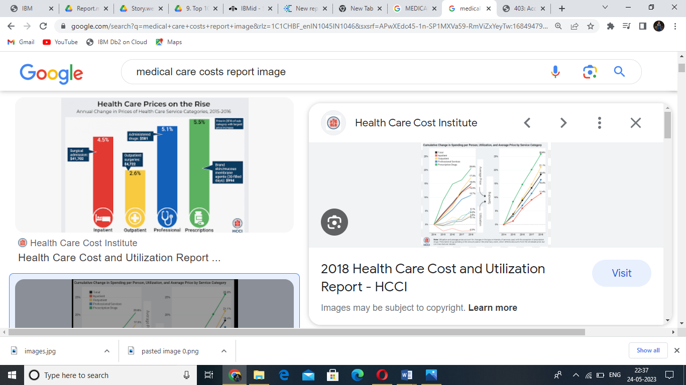

### 2.Web Integration

Publishing helps us to track and monitor key performance metrics, and to

communicate results and progress. help a publisher stay informed, make better

decisions, and communicate their performance to others.Integrating

dashboard/reports/stories to web .



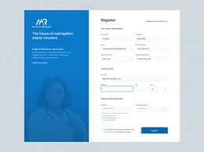

### 2.1Performance Testing

Performance testing is a type of software testing that is conducted to evaluate

the performance, responsiveness, scalability, stability, and speed of a software

application under a particular workload. The main goal of performance testing

is to ensure that the software application can handle the expected workload, and

perform optimally under various conditions.

### Amount Of Data Rendered To DB2

The amount of data that is rendered to a database depends on the size of the

dataset and the capacity of the database to store and retrieve data.

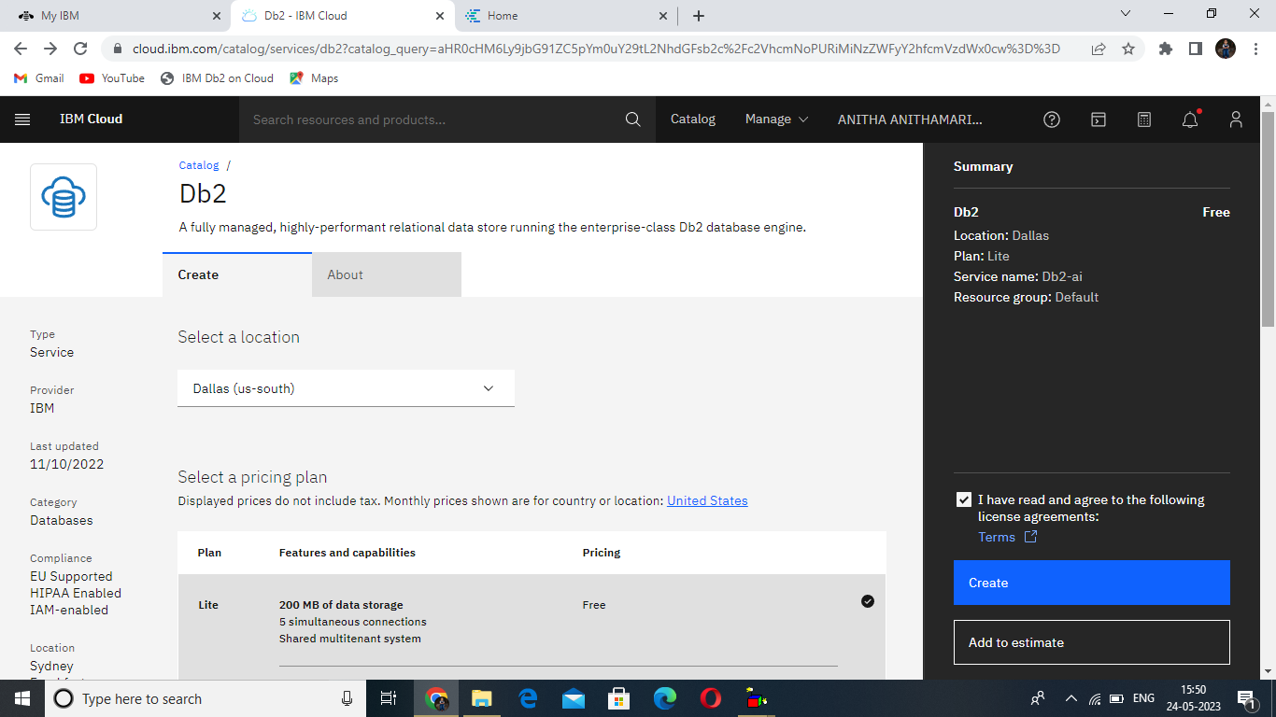

### 2.2Utilization Of Data Filters

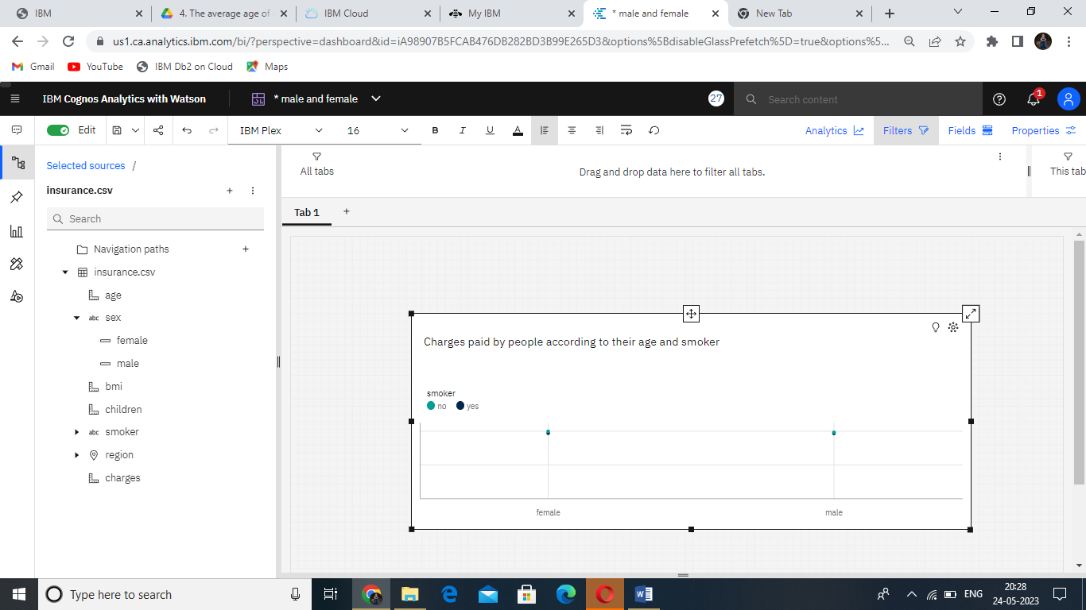

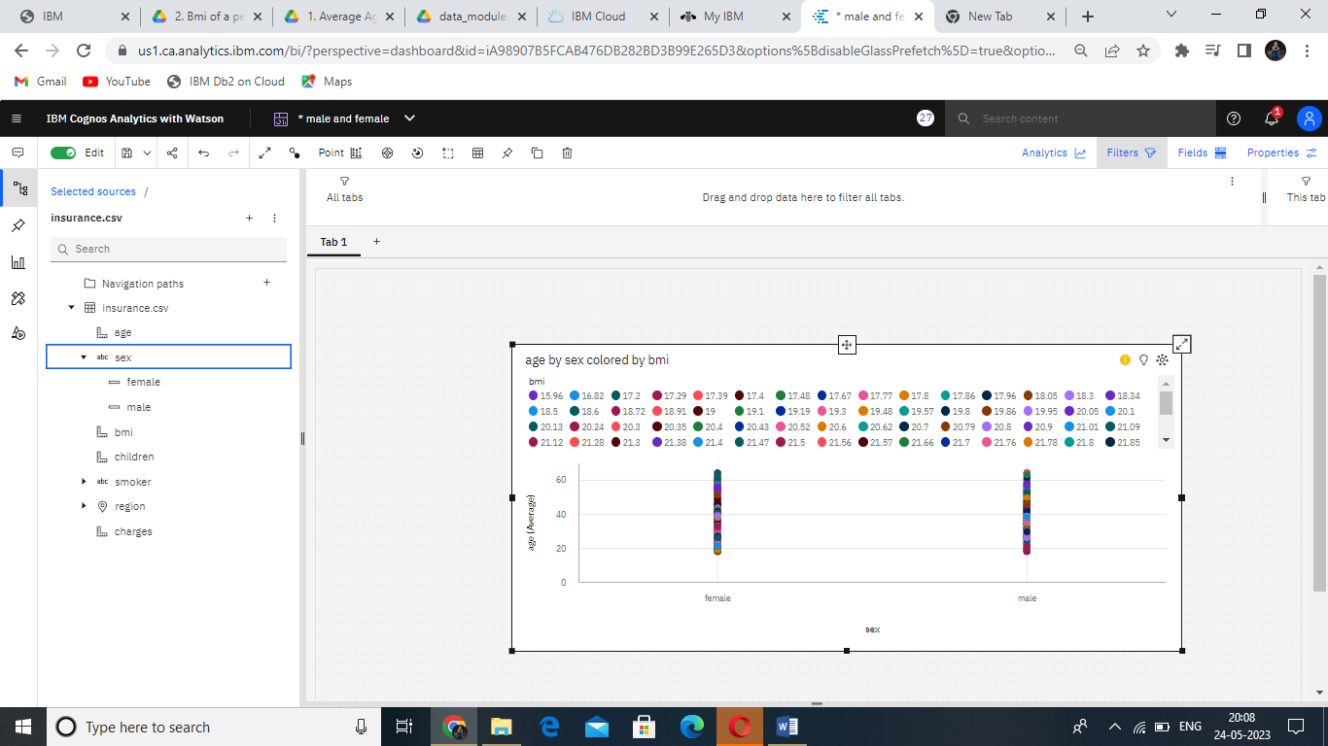

### 2.3 No Of Calculation Fields

### 

**Number Of Visualizations/ Graph**

1. Average Age of Male and Female
2. Bmi of a person by age
3. Number of children by age and smoker
4. The average age of people according to their region and gender
5. Charges paid by people according to their age and smoker

6.BMI of a person by their gender and smoker

7.Charges paid by people according to their gender, region and smoker

8..Average BMI of people by gender and region

9.Top 100 charges paid by people based on BMI and coloured by region

10. Number of Children to the people by region

### 

### 

### 

